Project Demonstration
Demo Walkthrough & Talking Points
Date | 04 October 2026
Team ID | SWTID-2026-6870
Project Name | Streamlining IT Procurement: Automating Standard Laptop Orders with Flow Designer
Maximum Marks | Not specified

1. Demo overview
This guide helps you present the project in about 5 to 7 minutes. It shows how a Standard Laptop order automatically produces a catalog task for the Hardware team.
Goal | Show that approved laptop orders create a Hardware configuration task without manual work
Platform | ServiceNow – Flow Designer and Service Catalog
Flow name | Standard laptop task
Catalog item | Standard Laptop (Hardware category)
Sample records | REQ0010001, RITM0010001, SCTASK0010001

2. Opening (30 seconds)
"IT teams often create laptop configuration tasks by hand, which causes delays. My project automates this with ServiceNow Flow Designer: when a Standard Laptop is ordered, a task is created and assigned to the Hardware team automatically."

3. Step-by-step demo

Step 1: Show the flow
Open Flow Designer and show the active flow Standard laptop task with the Service Catalog trigger.
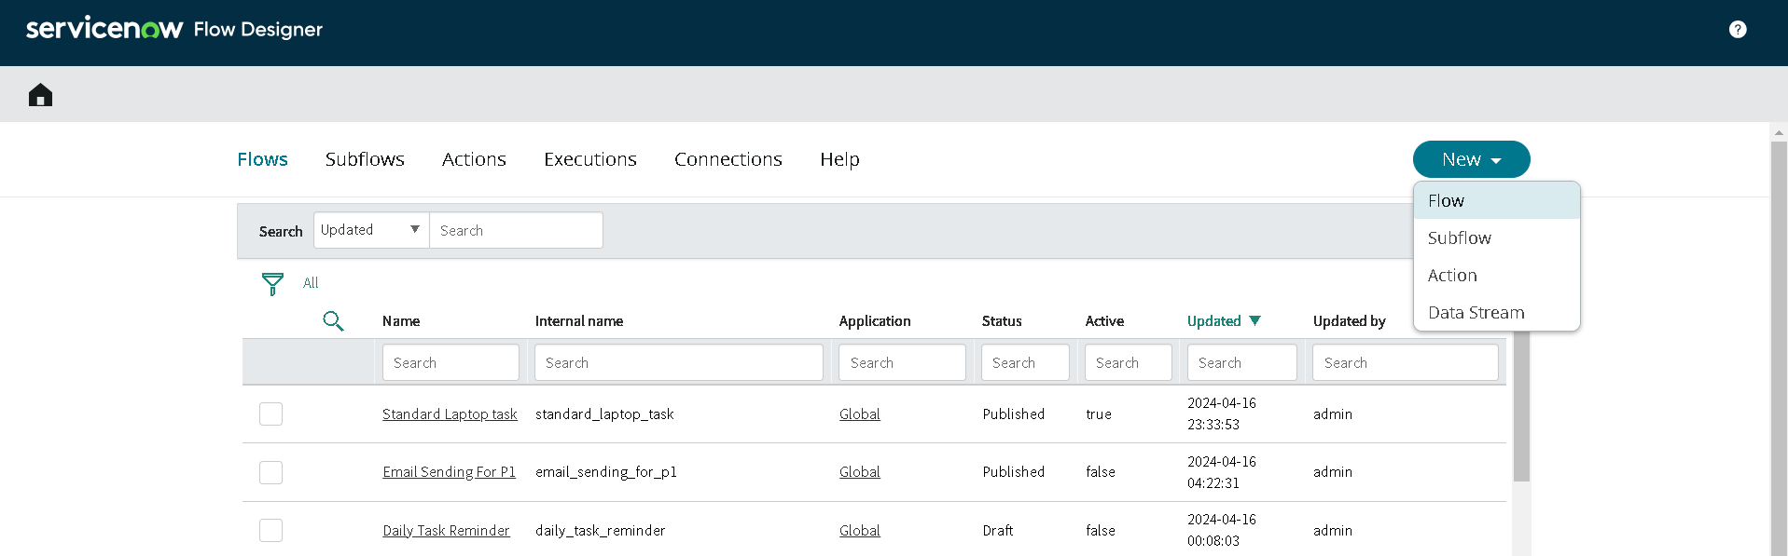
Flow list in Flow Designer

Step 2: Show the action
Open the Create Catalog Task action. Point out the Requested Item from the trigger, short description, Description, Assignment group Hardware and Approval Approved.
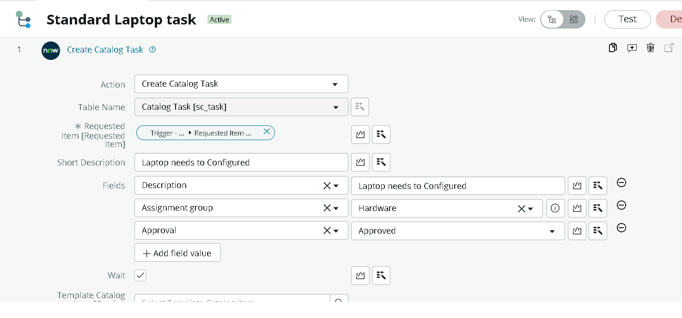
Create Catalog Task action

Step 3: Show the flow assignment
Open Maintain Items > Standard Laptop > Process Engine to show that the flow is attached to the catalog item.
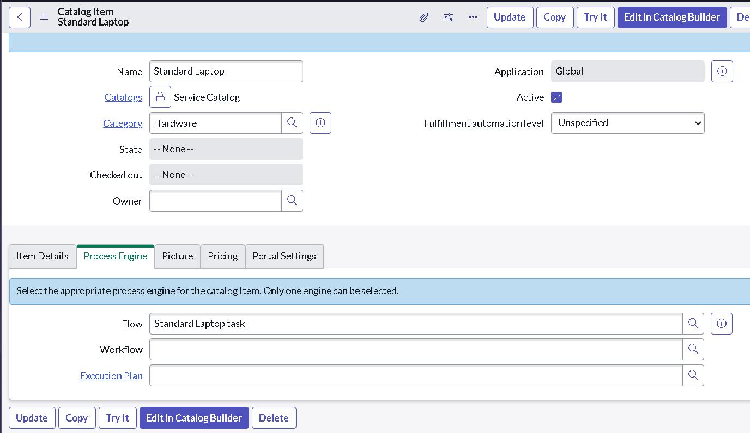
Process Engine tab

Step 4: Place the order
Go to Service Catalog > Hardware > Standard Laptop and click Order Now.
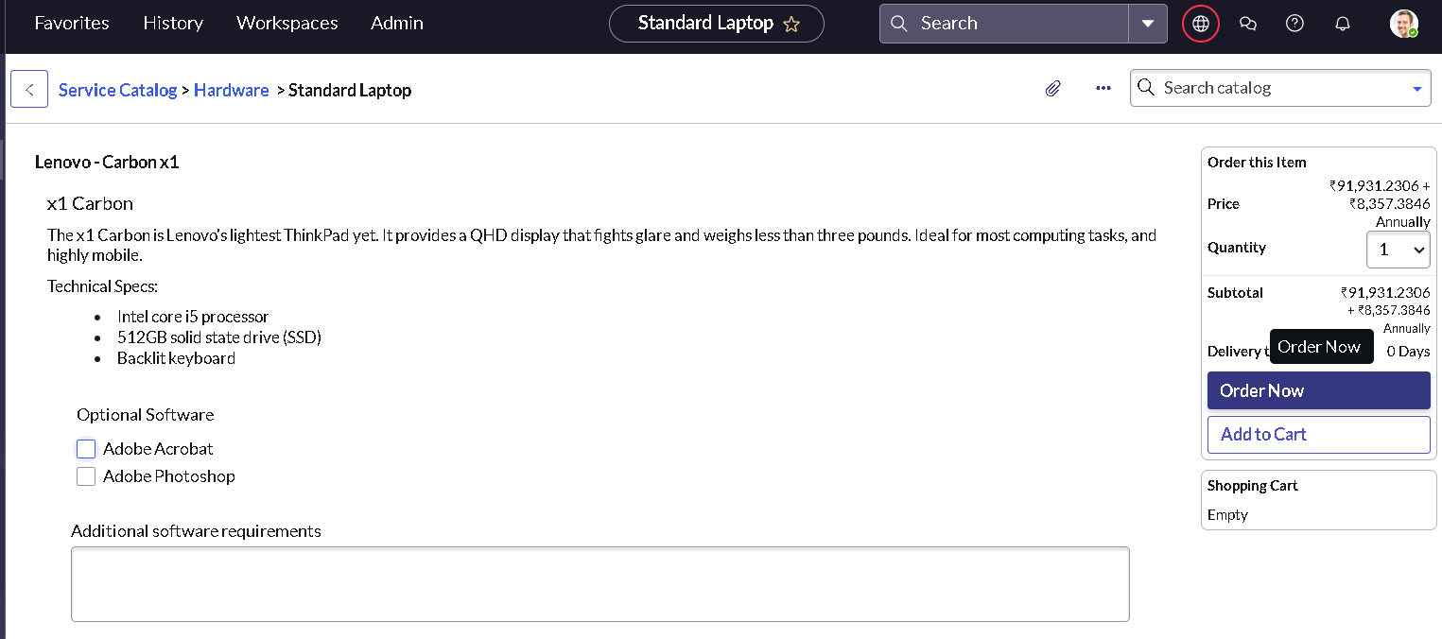
Standard Laptop catalog item
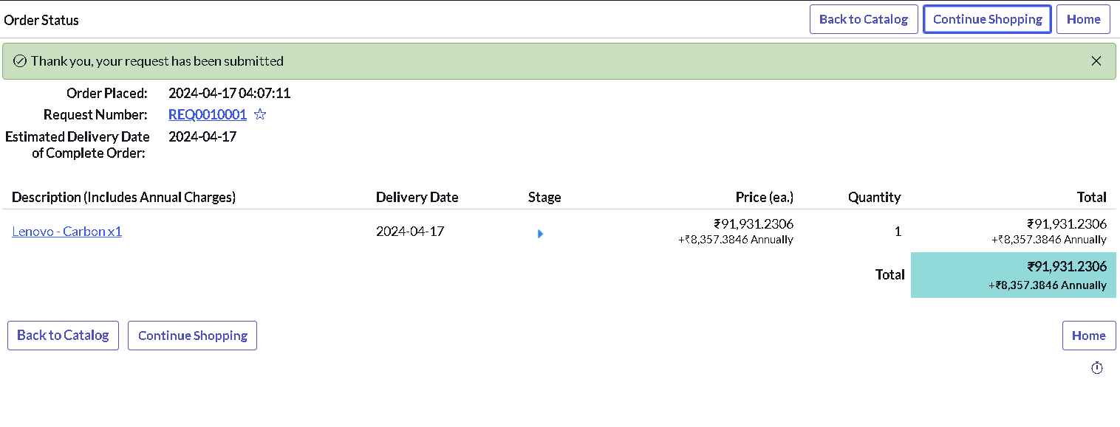
Order status with request number

Step 5: Approve the request
Open the request number, go to the Approvers tab, right-click the record and choose Approve.
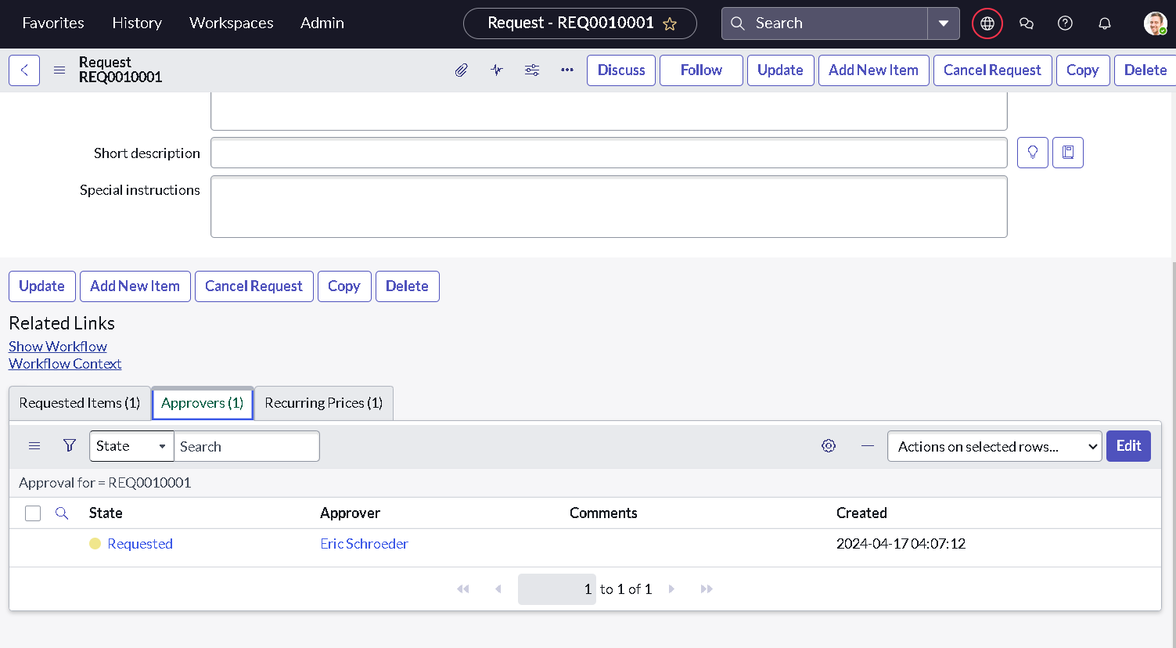
Approvers related list

Step 6: Show the generated task
Open the Requested Item and the Catalog Tasks tab. Show SCTASK0010001 assigned to the Hardware group, then open it to show the short description.
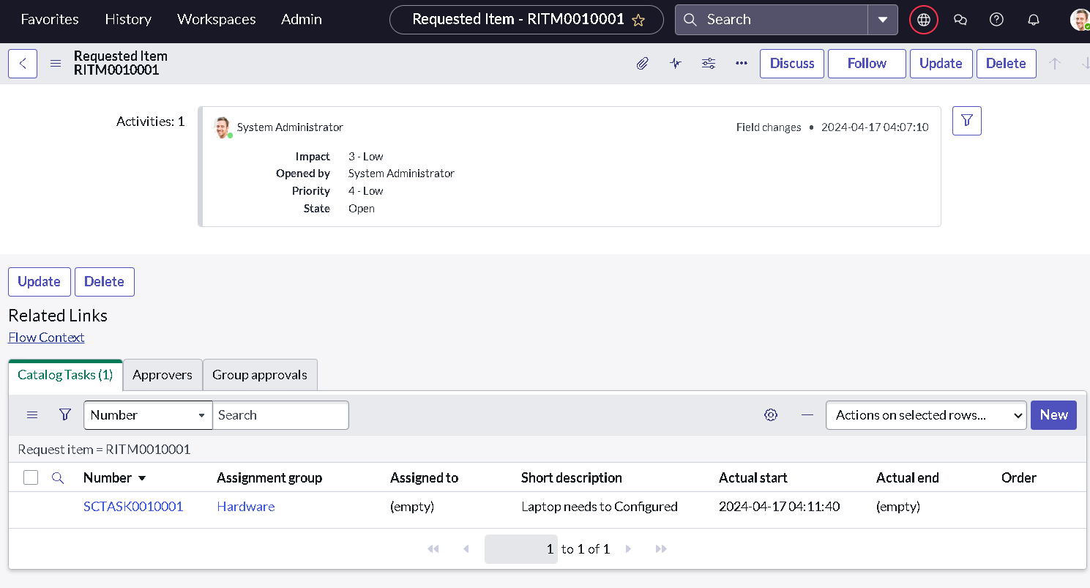
Catalog task under the Requested Item
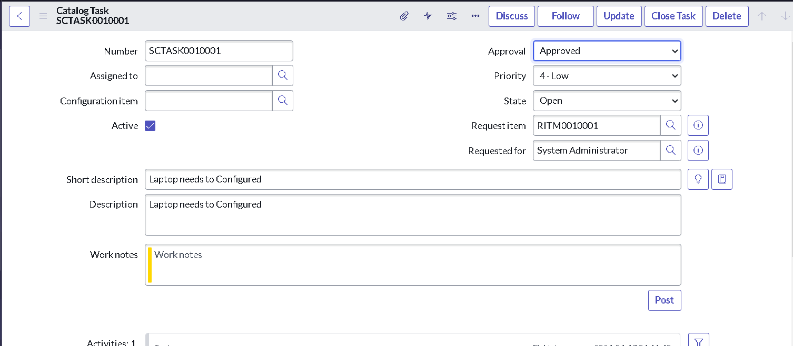
Catalog task details

4. Closing (30 seconds)
"With this flow, standard laptop orders create their configuration task automatically, reducing delays, manual effort and missed tasks. The same approach can be extended to other catalog items."

5. Possible questions and answers
Question | Suggested answer
Why Flow Designer instead of a workflow? | Flow Designer is the current low-code automation tool in ServiceNow and is easier to build, read and maintain.
Why Run As System User? | So the flow can create the task regardless of the requester's roles.
What does the Create Catalog Task action do? | It creates a record in the Catalog Task table linked to the Requested Item with the configured values.
How would you improve it? | Add an approval step inside the flow, notifications to the requester and SLA tracking.
Can it be reused? | Yes. The flow can be copied for other catalog items and assignment groups.

